FBISD ONLINE LEARNING

**Course: Introduction to Engineering**

**WEEK 6 ASSIGNMENT**: PRODUCT RESEARCH DOCUMENTATION (Information Sheet)

Student Name: David Han, Beryl Zhu

My Project Idea (solution): Clear Polycarbonate Antique Goblet Display Case with a Birchwood Base and Pedestal and a Metal Latch Locking Mechanism

Product #1 researched: Plymor Clear Arylic Display Case with Hardwood Base

Web link (URL): <https://www.collectingwarehouse.com/Box-Case-without-Base-4-x-4-x-6>

Comments: Notable aspects of this product include how the premium-grade acrylic allows a simple, clean, and contemporary look while the hardwood base adds a touch of elegance and grandeur to the display case. Additionally, the price actually decreases when the quantity bought increases, making it a greater appeal to consumers.

Picture: 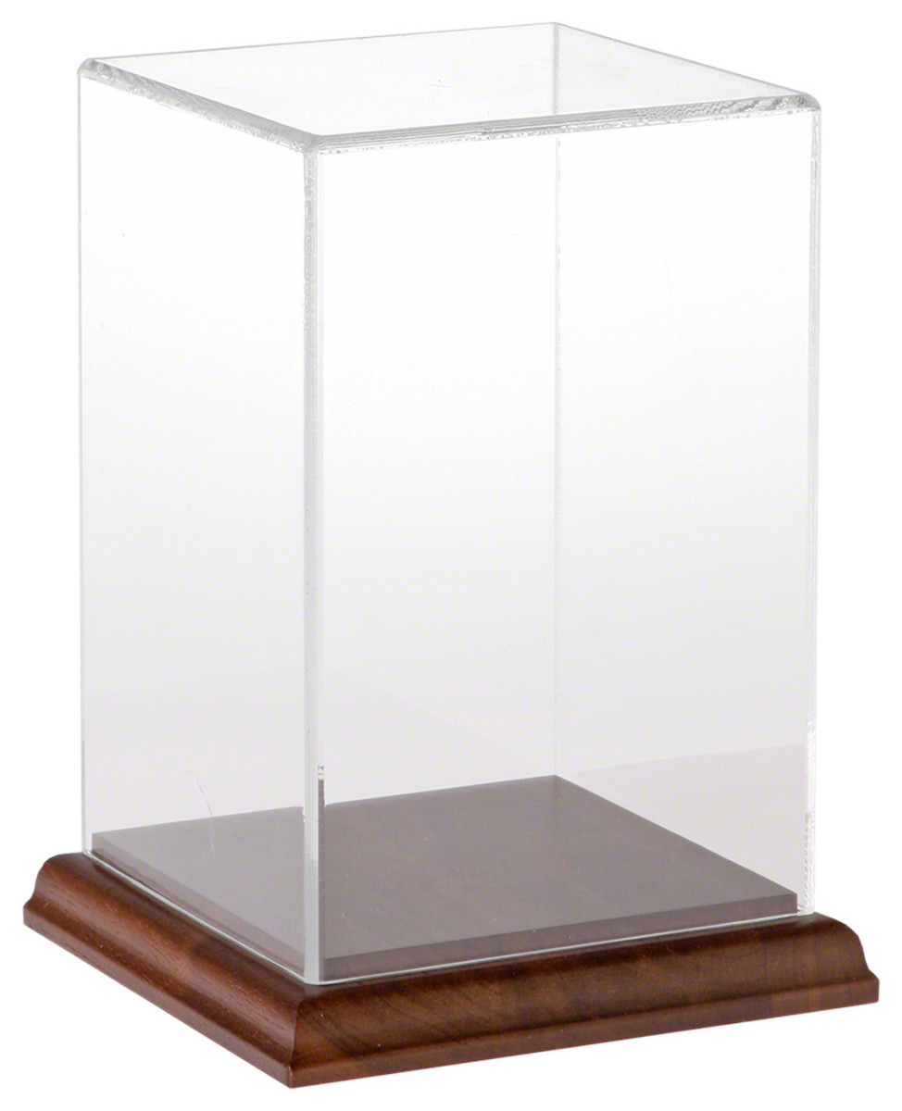

Product #2 researched: BOMARKEN Display Box

Web link (URL): <https://www.ikea.com/us/en/p/bomarken-display-box-gold-30454358/>

Comments: Interesting parts about this product include the steel frame which is painted gold to make it more visually appealing and luxurious looking. It also has a mirror on the back side to reflect whatever item is being displayed and can be placed down or hung up horizontally or vertically, providing versatility with where it can be placed.

Picture: 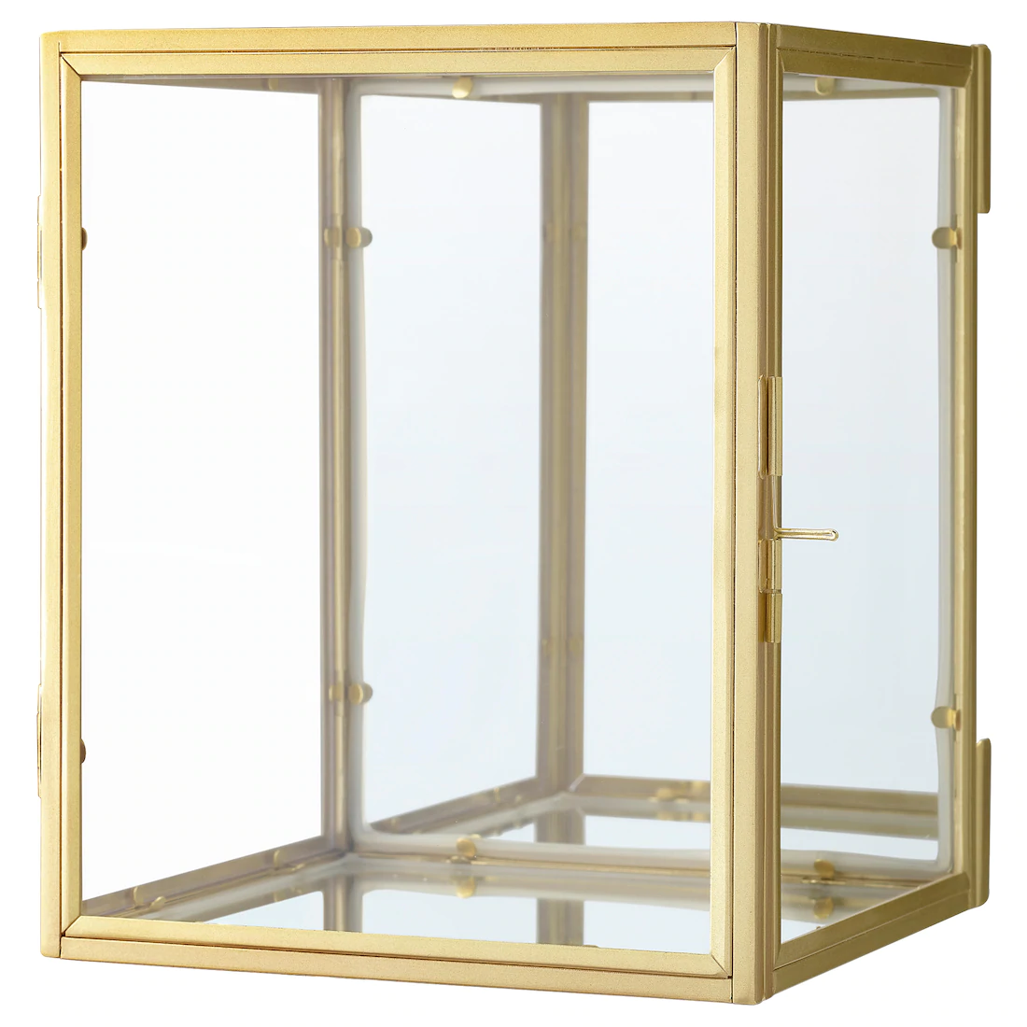

Product #3 researched: Plymor Acrylic Display Box Case with Hinged Lid

Web link (URL): <https://www.walmart.com/ip/Plymor-Acrylic-Display-Box-Case-With-Hinged-Lid/164112994?selected=true>

Comments: The box is completely clear and is made from the highest quality acrylic, which is robust and crack resistant. Regardless of viewing angle, you’ll get an amazing view of the object inside. With its minimalistic design, it’s sure to please and last a lifetime.

Picture: 